**POLITICAL JUGGERNAUTS**

A Quantitative Analysis Of Candidates In The 2019 Lok Sabha Elections

**1.INTRODUCTION :**

The Lok Sabha is composed of representatives of people chosen by direct election on the basis of Universal Adult Suffrage. The Constitution of India allows for a maximum of 550 members in the House, with 530 members representing the States and 20 representing the Union Territories. The 17th Lok Sabha was formed by the members elected in the 2019 Indian general election. Elections, all across India, were conducted in seven phases from 11 April 2019 to 19 May 2019 by the Election Commission of India.

* 1. OVERVIEW

The Bharatiya Janata Party received 37.36% of the vote, the highest vote share by a political party since the 1989 general election, and won 303 seats, further increasing its substantial majority. In addition, the BJP-led National Democratic Alliance (NDA) won 353 seats.

* 1. PURPOSE

 There were no similar discontinuities in the previous general elections for either BJP or Congress, the other major national party, as well as for state assembly elections held simultaneously with the 2019 general election and those held subsequently. Moreover, BJP’s disproportionate win of closely contested constituencies is primarily concentrated in states ruled by the party at the time of election.

**2. PROBLEM DEFINING& DESIGN THINKING:**

 Business Model/Impact: By conducting an analysis the Party can identify areas for improvement and take steps to enhance the Votes, and increase voter satisfaction and loyalty. Improve its Party reputation, which can lead to increased Voter loyalty.

**2.1 EMPATHY MAP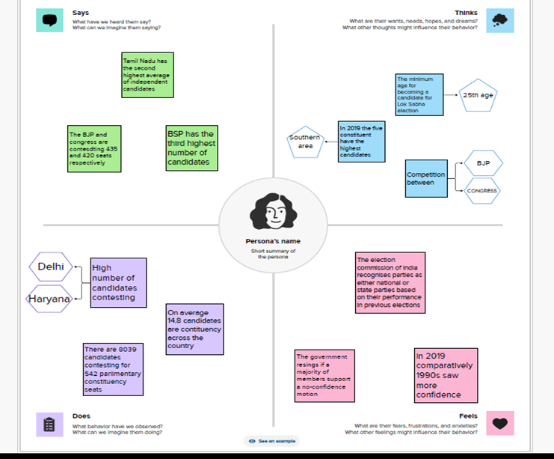2.2 BRAINSTROMING MAP**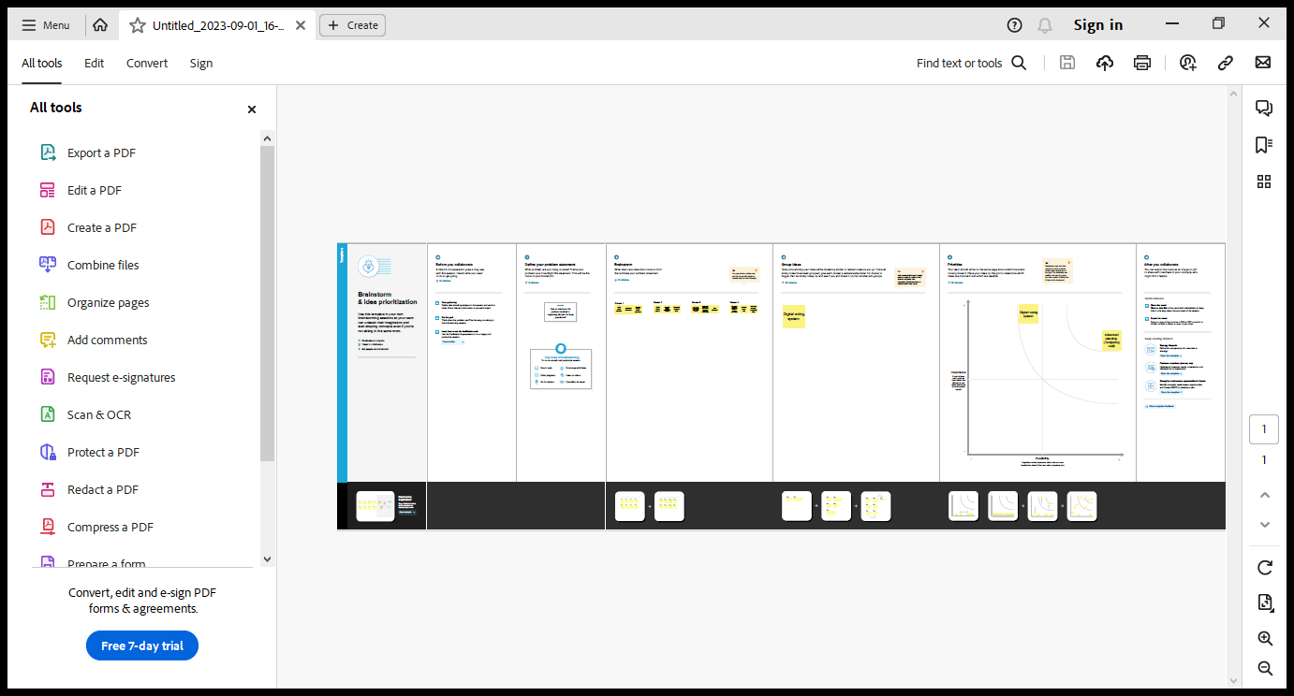

**3.RESULT** 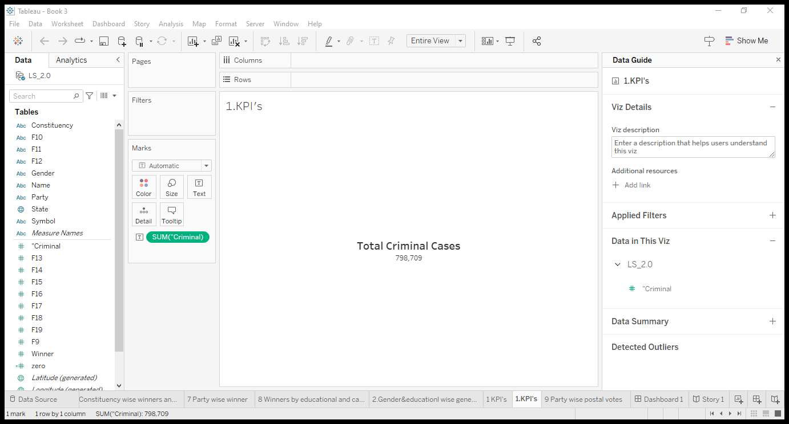

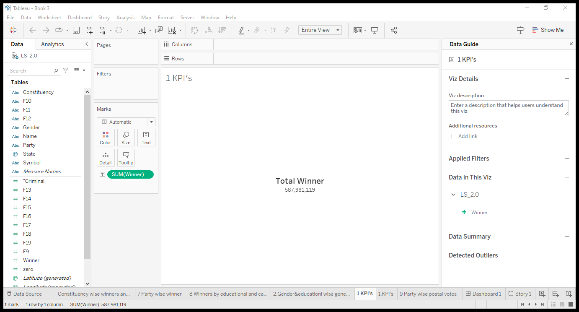

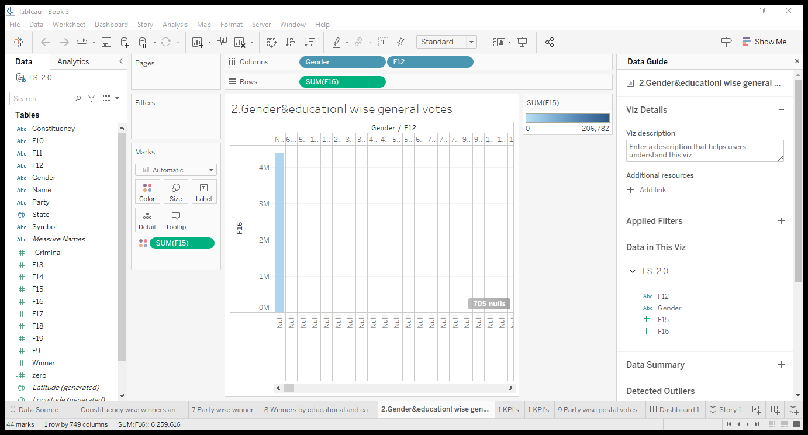

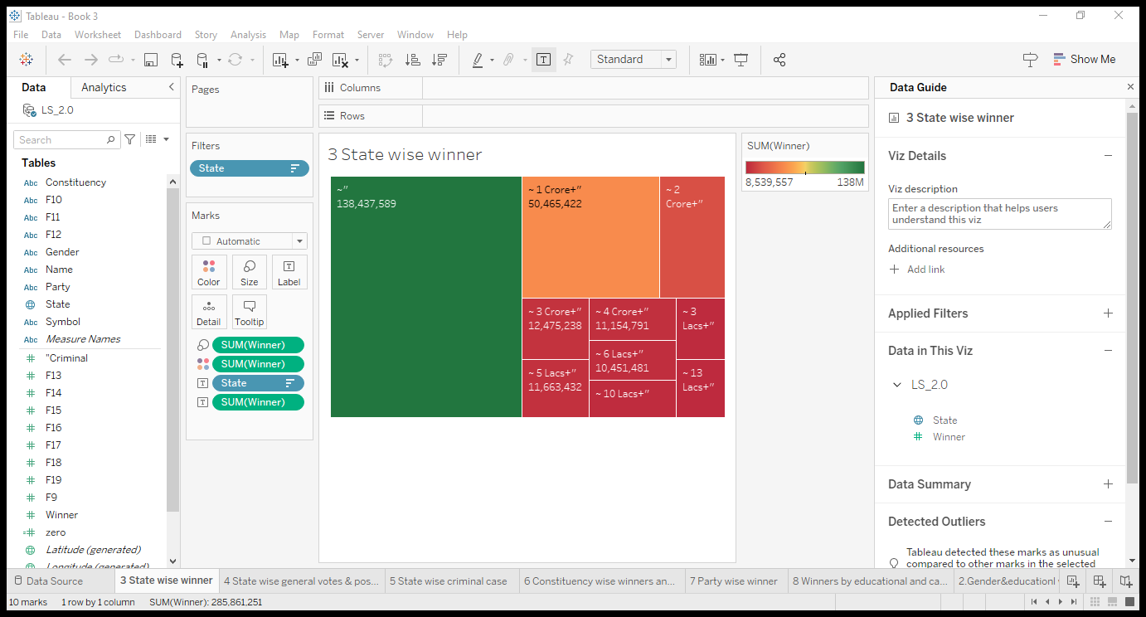

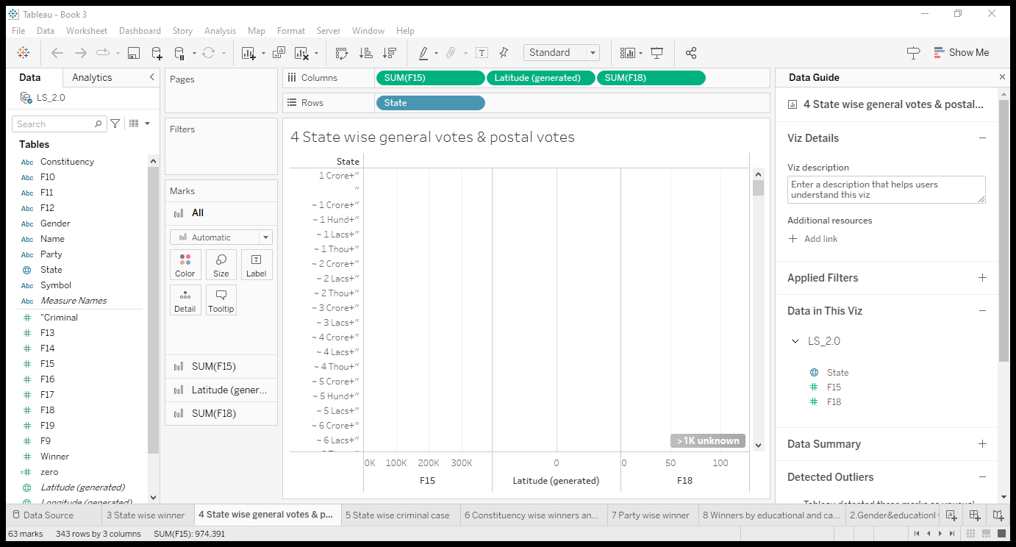

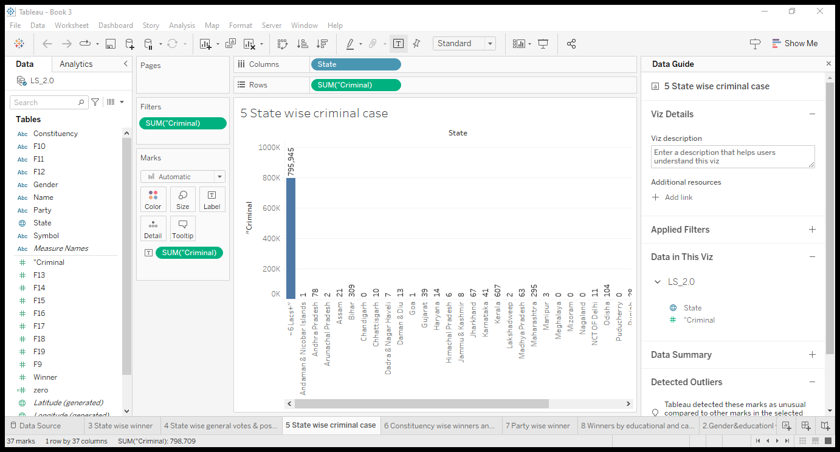

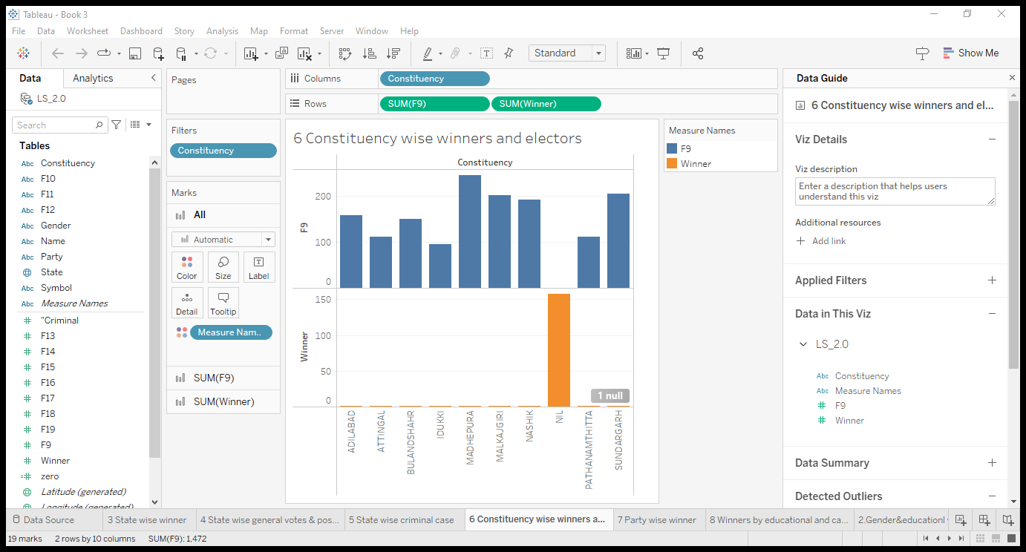

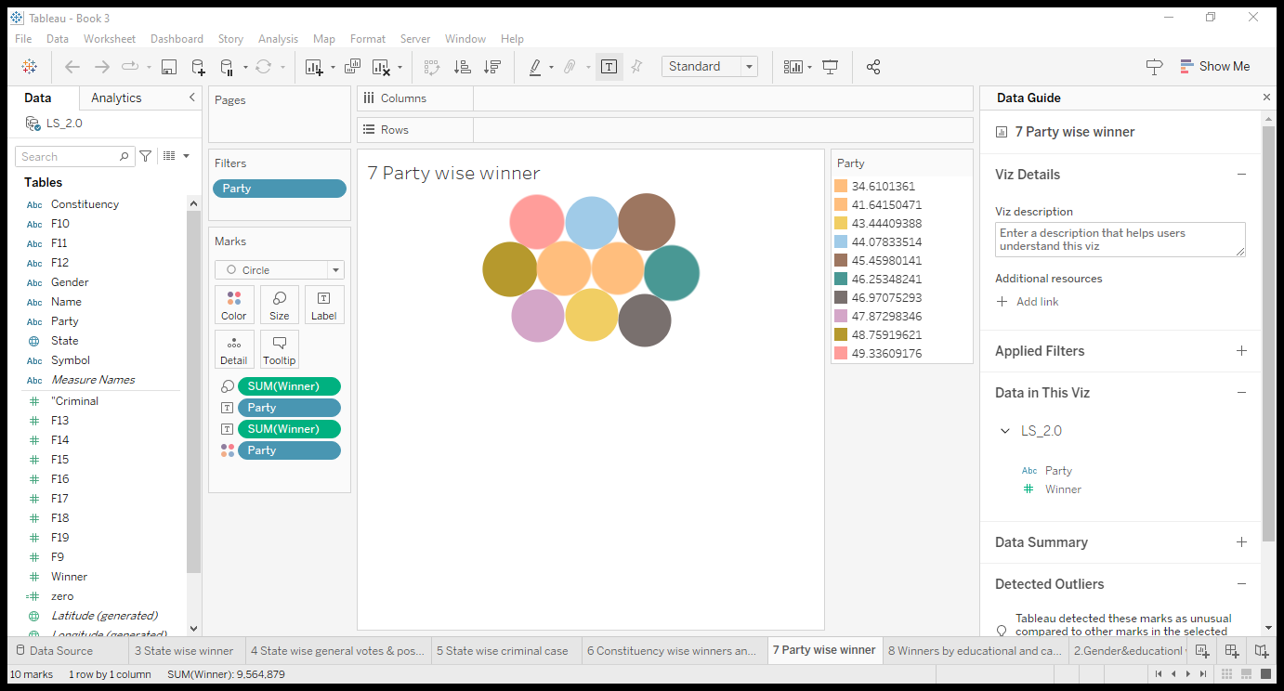

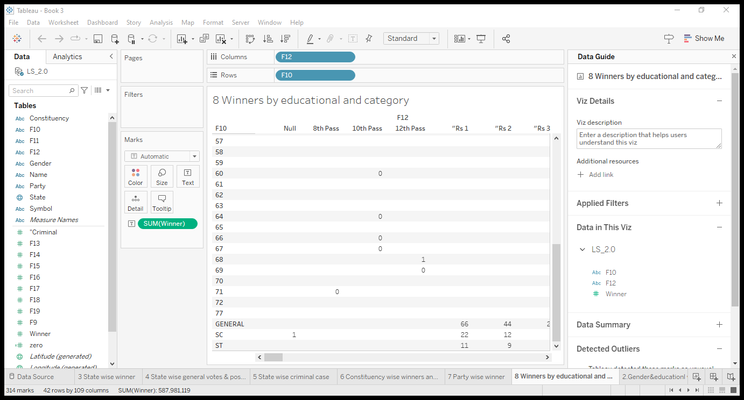

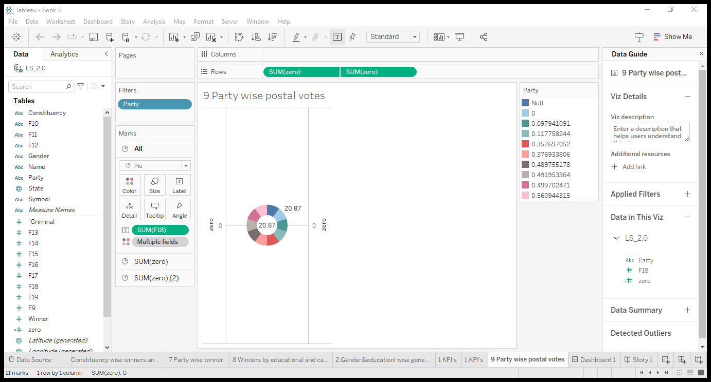

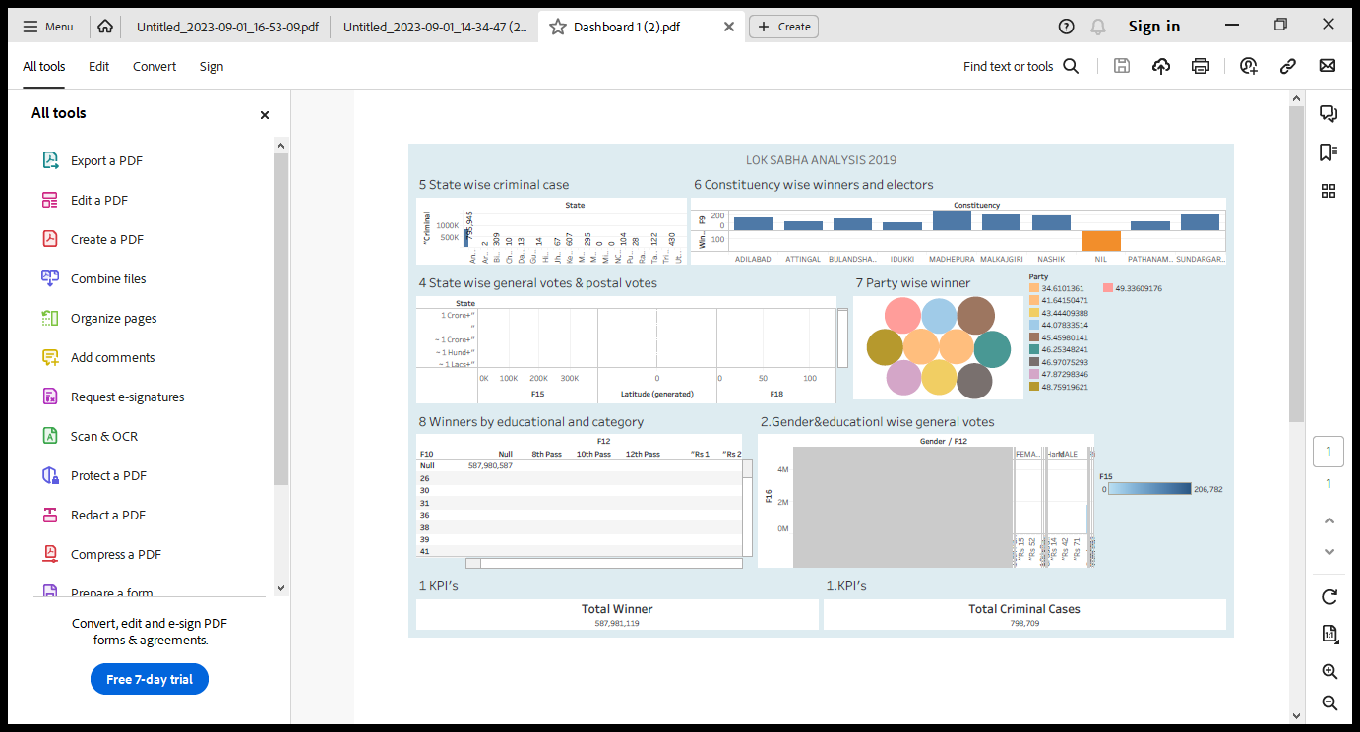

**4. ADVANTAGES & DISADVANTAGES**

**PROS:**

* When you disperse political power it allows people to protect themselves using that power for potential authoritarians (the other side of that coin is the tyranny of the majority, discussed below). Also, some argue that only you really know your best interests, and thus you should have a say in the process (even if it's through a representative).
* Elections also confer legitimacy on a state when done fairly (but also can serve to legitimize an autocratic state if not fair).
* Elections keep leaders compliant with at least the needs of the majority of the population, otherwise they will be voted out.

**CONS.**

* Voters don't have sophisticated knowledge and don't always make ideal policy decisions. Many voters are both uninformed about political issues and often use motivated reasoning because it's a shortcut and most people don't have time to become political experts.
* This isn't too much of a problem when you have legislators with autonomy, but can become problematic when populist movements try to take the reins. Legislators, on the other hand, are usually much more technocratic and rely on experts and science to inform their policies.

**5. APPLICATION**

 Neelanjan Sircar analyses the campaign of the Congress party, highlighting that it is important for Congress to leverage structural factors that exist in the economy such as unemployment and rural distress in the states of Gujarat, Madhya Pradesh, Chhattisgarh and Rajasthan, where it is in direct contest with the BJP to wean away some of the votes.

**6. CONCLUSION**

General elections were held in India in seven phases from 11 April to 19 May 2019 to elect the members of the 17th Lok Sabha. Votes were counted and the result was declared on 23 May. The election resulted in a landslide victory for the BJP which won 303 seats and formed the government.

**7. FUTURE SCOPE**

The Lok Sabha has certain powers that make it more powerful than the Rajya Sabha. Motions of no confidence against the government can be introduced and passed in the Lok Sabha.

